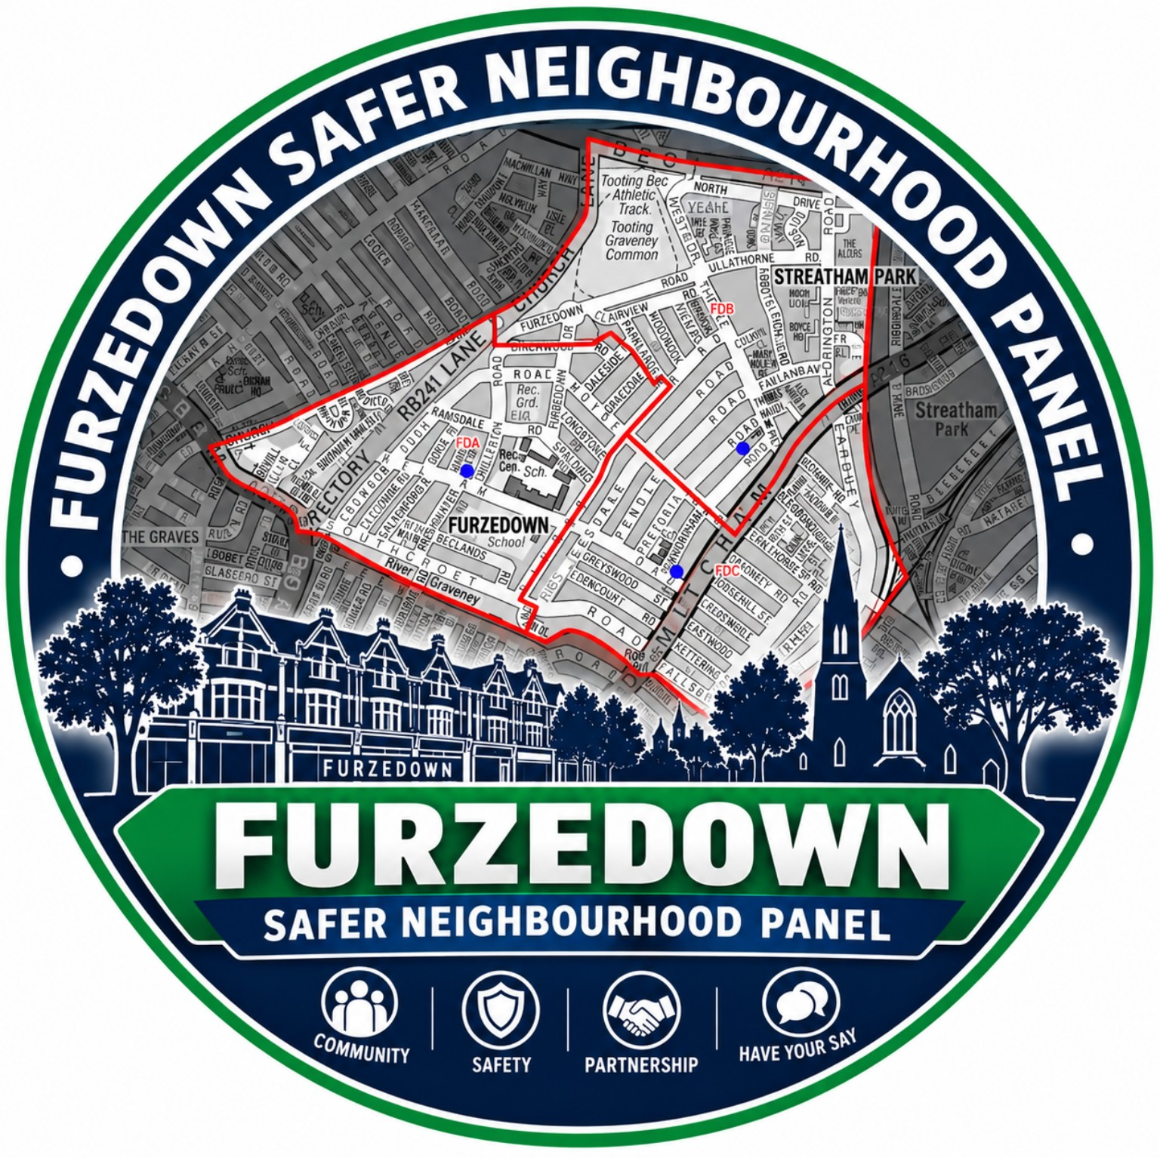
FURZEDOWN SAFER NEIGHBOURHOOD PANEL
THREE-YEAR
STRATEGIC PLAN
2026–2029
SAFER. STRONGER. CONNECTED.
A clear framework for resident voice, partnership working,
community safety and accountable local action.

OUR DIRECTION
Strategy at a glance
This plan sets out what the Panel is trying to achieve, how it will work with residents and partners, and how progress will be reviewed over the three-year period.
OUR VISION  To make Furzedown one of the safest, strongest and most connected neighbourhoods in Wandsworth through partnership with residents, the Metropolitan Police, Wandsworth Council and local organisations. | OUR MISSION  To represent the voice of local residents, identify community safety priorities, strengthen partnerships and support initiatives that reduce crime, tackle anti-social behaviour and improve community confidence.

Our values
Integrity | Transparency | Accountability | Respect
Inclusion | Partnership | Community leadership | Evidence-based decision making
Our six strategic priorities
1 Community engagement & communication | 2 Crime analysis & intelligence
3 Partnership working | 4 Governance & leadership
5 Crime prevention | 6 Monitoring & continuous improvement

STRATEGIC PRIORITIES
1–2: Residents and local intelligence
The first two priorities ensure that resident voice and reliable local information are at the centre of the Panel’s work.
1 | Community Engagement and Communication
AIM Engage residents and encourage community involvement.
WHAT WE WILL DO  - Hold quarterly public SNP meetings and two committee meetings each year.  - Increase resident participation and make it easier for people to have their say.  - Encourage volunteering and involvement in Neighbourhood Watch.  - Maintain community WhatsApp groups and use social media and community noticeboards.  - Publish an annual newsletter, attend local events and conduct resident feedback surveys. | HOW WE WILL KNOW WE ARE MAKING PROGRESS  - Meeting attendance increases over time.  - More residents respond to surveys and consultations.  - More residents volunteer or join Neighbourhood Watch activity.  - Resident satisfaction and confidence in the Panel improve.

2 | Crime Analysis and Intelligence
AIM Build a clearer understanding of local crime trends, hotspots and emerging concerns.
WHAT WE WILL DO  - Review police crime statistics and updates.  - Identify hotspots, patterns and emerging issues.  - Gather resident intelligence and record local concerns and repeat incidents.  - Produce and circulate clear meeting minutes so actions and concerns are visible. | HOW WE WILL KNOW WE ARE MAKING PROGRESS  - Hotspots and recurring issues are identified more consistently.  - Residents and partners have a clearer understanding of local crime trends.  - Information supports better targeted interventions and follow-up.

STRATEGIC PRIORITIES
3–4: Partnership and good governance
Strong partnerships and transparent governance give the Panel the structure needed to turn resident concerns into coordinated action.
3 | Partnership Working
AIM Strengthen collaboration with key partners across Furzedown and Wandsworth.
WHAT WE WILL DO  - Hold regular partnership discussions and maintain constructive working relationships.  - Share information appropriately and raise local concerns with the right organisations.  - Promote safeguarding, prevention and community resilience through joint working.  CORE PARTNERS  - Metropolitan Police and Wandsworth Council  - Local councillors, schools and Furzedown Youth Club  - Churches, local businesses and resident associations  - Neighbourhood Watch and community organisations | HOW WE WILL KNOW WE ARE MAKING PROGRESS  - More joint initiatives are developed.  - Partnership relationships are stronger and more consistent.  - Local issues are escalated and responded to more quickly.

4 | Governance and Leadership
AIM Ensure the Panel operates effectively, transparently and with clear accountability.
WHAT WE WILL DO  - Maintain clear committee roles, including Chair, Vice Chair, Secretary, Neighbourhood Watch Coordinator, Youth Representative and committee members; Treasurer where required.  - Maintain the core governance documents: Constitution, Strategic Plan, Code of Conduct and meeting minutes.  - Hold regular elections and keep decisions, actions and responsibilities clear. | HOW WE WILL KNOW WE ARE MAKING PROGRESS  - Elections take place regularly.  - Committee attendance remains strong.  - Responsibilities and decisions are clear and transparent.  - Agreed actions are completed and followed up.

STRATEGIC PRIORITIES
5–6: Prevention, performance and learning
The Panel will focus on agreed community safety priorities while reviewing evidence and outcomes so activity can adapt when local needs change.
5 | Crime Prevention
AIM Support initiatives that improve community safety and respond to the priorities identified through residents, police information and partnership working.
WHAT WE WILL DO  - Support proportionate crime-prevention and awareness activity.  - Use resident feedback and crime information to focus attention on priority areas.  - Work with partners to support targeted interventions where concerns are recurring or concentrated.  - Review community safety priorities as part of the annual review.  CURRENT PRIORITY AREAS  - Anti-social behaviour (ASB)  - Violence Against Women and Girls (VAWG)  - Robbery  - Vehicle crime | HOW WE WILL KNOW WE ARE MAKING PROGRESS  - Crime-prevention activity is focused on identified local needs.  - Partners are able to target activity more effectively.  - Resident concerns and priority areas are reviewed and acted on.

6 | Monitoring and Continuous Improvement
AIM Measure progress, review performance and improve the Panel’s work over time.
WHAT WE WILL DO  - Monitor crime statistics, police updates, resident concerns, communications and progress against actions.  - Review achievements and priorities annually.  - Publish an Annual Report and use learning to improve future activity. | HOW WE WILL KNOW WE ARE MAKING PROGRESS  - Objectives are tracked and reviewed.  - Resident feedback is positive and informs improvement.  - Actions are followed through and lessons are carried into the next year.  - Priorities remain responsive to local evidence and community concerns.

PERFORMANCE
How we will measure progress
The Panel will use a small, practical set of indicators to understand whether engagement, partnership activity, governance and community safety work are improving. Measures should be considered alongside qualitative feedback from residents and partners.
Area | What we will monitor | Review point
Resident engagement | Public meeting attendance; survey participation; resident feedback | Quarterly / annual review
Communication | Newsletter distribution and reach; use of community communication channels | Annual review
Community involvement | Volunteering and Neighbourhood Watch participation | Annual review
Community safety | Trends and concerns relating to ASB, VAWG, robbery and vehicle crime; other emerging local issues | At public meetings / annual review
Partnership working | Joint activity, partner engagement and follow-up on local issues | Quarterly / annual review
Governance | Committee attendance, elections, completed actions and clear records of decisions | Committee review / annual review
Resident confidence | Resident satisfaction and confidence in local community safety arrangements | Annual survey / feedback
Annual review cycle
1. LISTEN  Gather resident concerns, survey feedback and local intelligence. | 2. REVIEW  Consider crime data, police updates, partnership information and action progress.
3. PRIORITISE  Confirm or refresh community safety priorities and agree the next actions. | 4. REPORT  Publish progress, record decisions and share an annual summary with residents.

DELIVERY ROADMAP
Three-year delivery plan
The roadmap gives each year a clear purpose. It is designed to build strong foundations first, then expand delivery, and finally review impact and prepare the next strategy.
YEAR ONE | 2026–2027  BUILD STRONG FOUNDATIONS | - Strengthen governance and clarify committee roles.  - Recruit and retain committee members.  - Improve resident engagement and meeting participation.  - Launch an annual resident survey.  - Publish the Panel newsletter.

YEAR TWO | 2027–2028  DELIVER AND GROW | - Expand Neighbourhood Watch involvement.  - Deliver crime-prevention campaigns.  - Increase youth engagement.  - Strengthen partnerships with schools and community organisations.  - Review Year One progress and adjust delivery where needed.

YEAR THREE | 2028–2029  REVIEW AND SUSTAIN | - Review the Strategic Plan and measure outcomes.  - Refresh community priorities using evidence and resident feedback.  - Publish a three-year impact report.  - Identify what should be sustained or improved.  - Develop the 2029–2032 Strategic Plan.

Our commitment
This strategy provides a clear framework for improving community safety through strong governance, effective partnerships, resident engagement and evidence-based action. The Panel will review progress each year, remain responsive to changing local concerns and keep residents informed about what has been achieved and what needs further attention.

